Computer Language Diagrams

System Interface in a Diagram
The principle of the system interface is explained in the article System Interface. The current article only explains its expression in a diagram.

When an object has several interfaces, each interface is drawn out as a triangle, contained by the object:

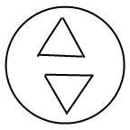

The complete notation for interfaces is explained in later articles. The system interface uses an alternative notation for an interface. Interfaces of an object are part of the target object, but the system interface is not part of the target object, but part of the symbol representing the target object. Therefore, the triangle that is to represent the system interface is stuck to the border of the symbol:

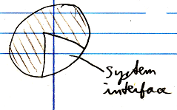

To make more room inside the system interface, sometimes the following an exaggerated notation is used:

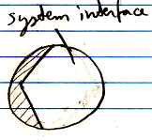

The system interface contains the members that hold the configuration of the symbol. The main item of the configuration is the data and commands, that determine what object the symbol is pointing to:

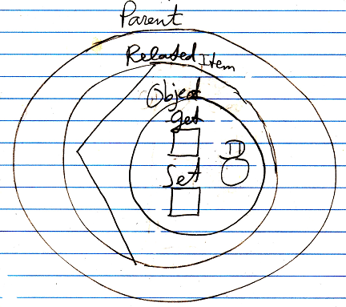

Because there will be other parts of the system interface, than just the configuration of the target object, the settings for the target object are contained inside a circle named Object. The object part of the system interface contains the members ID, Get and Set .

As such, all members of the system interface will all be displayed inside this triangle, stuck to the border of an object symbol.

A command symbol also has a system interface.

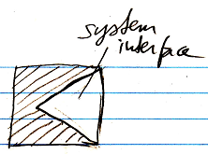

Or with an exaggerated notation:

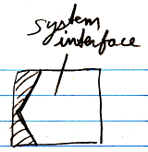

The default members of the system interface of a command symbol are shown belown:

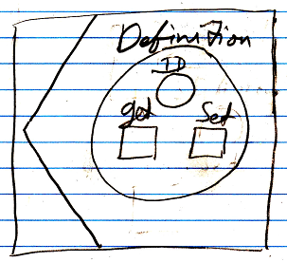

Normally, the system interface is not shown. Normally, the contents of the target object are shown inside the symbol.
Showing the system interface is like breaking open the symbol to see its internal workings to adapt its configuration.
When the system interface is shown, the contents of the target object may not be shown inside the symbol anymore. The target of the object will be connected to the Object . ID of the system interface.

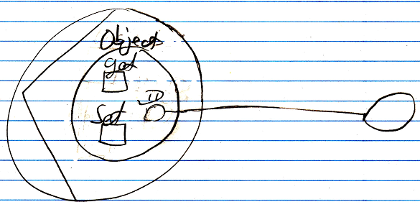

See also: System Interface, Interface in a Diagram (may not be written yet)

Author & Copyright: Jan-Joost van Zon Date: June 8, 2008 – June 8, 2008 Location: Oosterhout, The Netherlands Status: Finished

